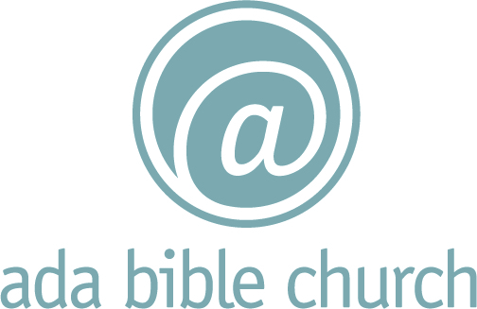

Family Ministry Covenant
Don’t let anyone look down on you because you are young, but set an example for the believers in speech, in love, in faith and in purity. – I Timothy 4:12 NIV

If you are not able to fill a leadership role in light of the guidelines below, we still have great opportunities for you to serve as you continue to grow in your relationship with the Lord.
By stepping into a leadership role (staff, storyteller, small group leader, worship leader,coach, or room leader) in one of our Family Ministry environments (nursery, Discovery Village, Lifeline) you are stepping into a position of responsibility and authority. Children, teens, and young parents will watch you closely, take what you say seriously, and follow you as a role model. If what you say and teach is not consistent with your behaviors in your various roles throughout the week, your impact will be minimized.
There are three lifestyle issues that tend to surface frequently in our current culture that can have a lasting impact on children and youth. Below are the expectations that volunteer leaders/staff in Family Ministry are expected to communicate and to model.
Sexual Behavior
Ada Bible Church believes that the scriptures teach that sex was created by God as an expression of intimacy between a man and woman within the context of marriage. Therefore, we ask that you personally embrace lifestyles and behaviors consistent with this teaching. If you are involved in any of the following, we ask that you not volunteer/work in Family Ministry leadership at this time.

- If you are involved in a sexual relationship and are not married
- If you are pursuing a same sex relationship
- If you are single and living with a member of the opposite sex
- If you are married and are currently involved in a sexual relationship outside of your marriage
Substance Abuse
If you have a history of substance abuse, this might be something God uses in a positive way to steer a future generation in a different direction. If this is part of your message, we would love to talk with you. However, if any of the following is true, we ask that you not volunteer/work in Family Ministry leadership at this time.
- If you have been arrested for or convicted of an alcohol or drug related offense in the past year
- If you are currently being treated for alcohol or drug abuse
- If you have used any illegal substance during the past year
- If you are consuming alcohol to the point of intoxication, or to the point of it being illegal for you to drive yourself home as a regular part of your weekend or weeknight routine
Social Media
Students and even their parents may visit your Facebook page, blog, or follow you on Twitter, etc. While social media can be a great connection tool, it also serves as a window into your life beyond church. We ask that you leverage social media with students in mind and consider the following:
- Use modest photos and avoid photos with alcohol in them, especially those that show you drinking
- Avoid using inappropriate language, including in text form
_____________________________ ______________________________
Staff Signature Date

